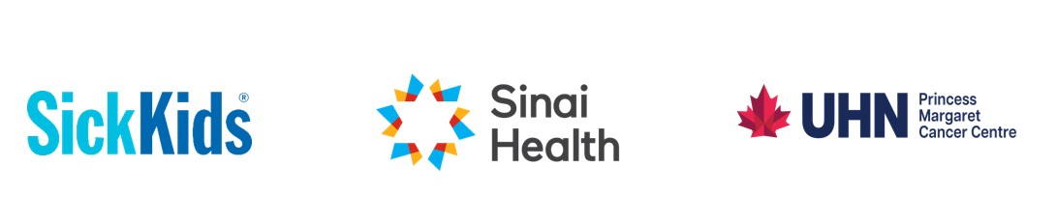**20th International p53 Workshop**- **Abstract Submission Template**

**Submission Deadline: December 31, 2025 (5pm EDT)**

**Notification of acceptance: January 30, 2026**

|  |
| --- |
| **Title of study/project:** |
| **Authors and institutional affiliation:** *Example: Malkin D, University of Toronto*  *Kirsch D, Princess Margaret Cancer Center*  *Schramek D, Lunenfeld-Tanenbaum RI* |
| **Email of submitting/first author:** |
| **Training program first author is enrolled in:** *First Author is required to be enrolled in a training program during 2025-2026. Example: Radiation oncology Residency Program* |
| **Year of training:** *Example: PGY 3* |
| **Abstract:** *Approx. 300 words*  *Suggested format: Purpose, Materials and Methods, Results, Conclusions* |

Please email your submission to us at XX. Please use the following subject heading: Abstract- p53 International workshop