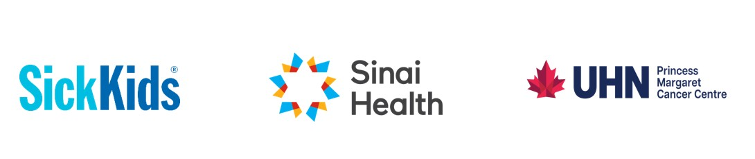20th International p53 Workshop- Abstract Submission Template
Submission Deadline: January 31st 2026 (5pm EDT)
Notification of acceptance: By or before February 27, 2026

Title of study/project:
Authors and institutional affiliation: Example: Malkin D, University of Toronto
Kirsch D, Princess Margaret Cancer Center
Schramek D, Lunenfeld-Tanenbaum RI
Email of submitting/first author:
Training program first author is enrolled in: First Author is required to be enrolled in a training program during 2025-2026. Example: Radiation oncology Residency Program
Year of training: Example: PGY 3
Abstract: Approx. 300 words
Suggested format: Purpose, Materials and Methods, Results, Conclusions
Please email your submission to us at p53workshop2026@uhn.ca . Please use the following subject heading: Abstract- p53 International workshop

